|  |  |  |
| --- | --- | --- |
| DATASET | CHARACTERISTICS | REFERENCE LINK |
| 1.Synthetic Training for Accurate 3D Human Pose and Shape Estimation in the Wild . | Synthetic Training for Real Accurate Pose and Shape (STRAPS), a deep-learning-based framework that uses synthetic training data to overcome the lack of shape diversity in current datasets.  The SSP-3D evaluation dataset, which we use to show that our results are in better shape prediction accuracy than other competing approaches. | <https://arxiv.org/pdf/2009.10013v2.pdf> |
| 2. Detecting Attended Visual Targets in Video | Gaze behavior is a critically-important aspect of human social behavior, visual navigation, and interaction with the 3D environment .  Our goal is to identify where each person in each frame of a video is looking, and correctly handle the case where the gaze target is out-of-frame.  It is a VideoAttentionTarget dataset which aims at detecting the time-varying attention targets for each person in a video. Our model is designed to allow the face to direct the learning of gaze-relevant scene regions | <https://arxiv.org/pdf/2003.02501v2.pdf> |
| 3.Analysis of Human Action and Trajectory Prediction in Video | Humans navigate through public spaces often with specific purposes in mind, ranging from simple ones like entering a room to more complicated ones like putting things into a car. Even though their intentions might be determined early, their future trajectories might also be altered by other constraints like social interactions and scene constraints .Our goal is to jointly analyze scene semantics and human actions to predict their future trajectories. | <https://arxiv.org/pdf/2011.10670v3.pdf> |
| 4.Human Activity Recognition Using Vision-Based Method | The vision-based HAR research is the basis of many applications including video surveillance, health care, and human-computer interaction (HCI). This review highlights the advances of state-of-the-art activity recognition approaches, especially for the activity representation and classification methods  this review aims to provide a comprehensive introduction to the video-based human activity recognition | <https://www.hindawi.com/journals/jhe/2017/3090343/> |

1. **Synthetic Training for Accurate 3D Human Pose and Shape Estimation in the Wild .**

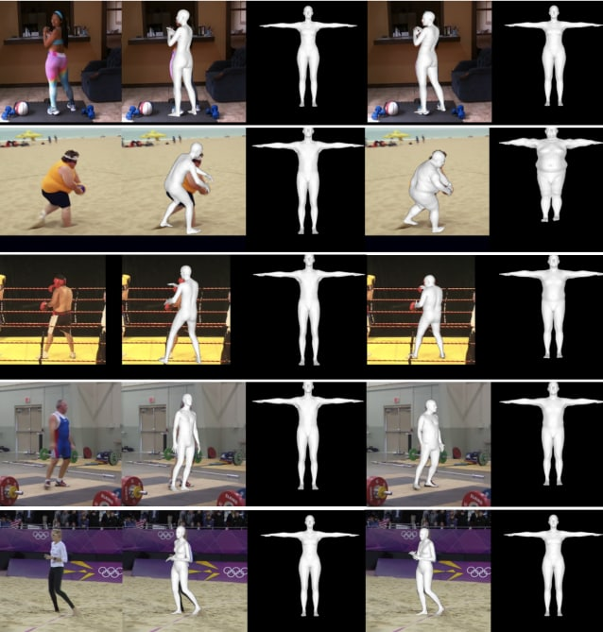

**2.Detecting Attended Visual Targets in Video** 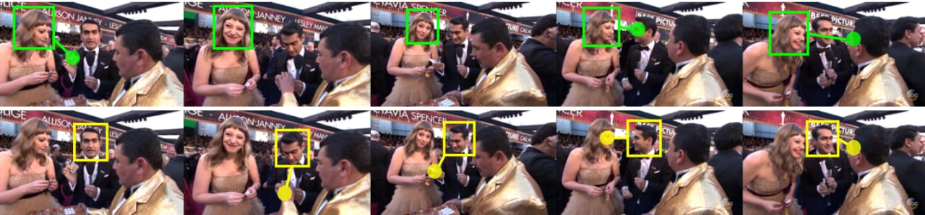

**3.Analysis of Human Action and Trajectory Prediction in Video**

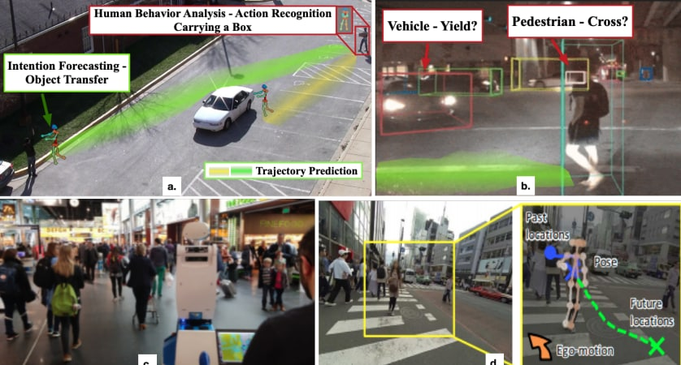

**4.Human Activity Recognition Using Vision-Based Method**

